**STATISTICS**

**ASSIGNMENT-5**

**EXERCISE 1.**

Answer the following questions by calculating the number of ways of obtaining particular arrangements of objects and events.

1. An athlete has eight different trophies, but only has room for four trophies in a display cabinet. How many different ways is it possible to display just four trophies out of eight, assuming that the display order is important?

$$P\left(8,4\right)= \frac{8!}{\left(8-4\right)!}=8*7*6*5=1680$$

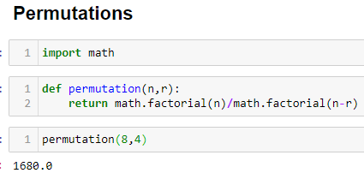

1. A football manager has a squad of 20 players. How many different teams of 11 players could be selected from the squad? (Hint: Assume that positions of the players are not important)

$$C\left(20,11\right)= \frac{20!}{\left(20-11\right)!*(11!)}=167960$$

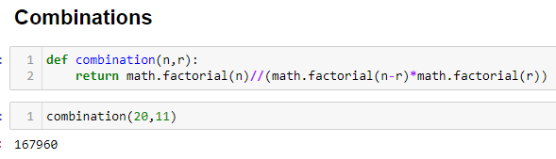

**EXERCISE 2.**

Are people happy in their marriages? The table shows results from the 2008 General Social Survey for married adults classified by gender and level of happiness.

|  |  |  |  |  |
| --- | --- | --- | --- | --- |
| **Gender** | **Very Happy** | **Pretty Happy** | **Not too Happy** | ***Total*** |
| Male | 183 | 243 | 43 | ***469*** |
| Female | 215 | 247 | 38 | ***500*** |
| ***Total*** | ***398*** | ***490*** | ***81*** | ***969*** |

1. Estimate the probability that a married adult is very happy.
$$\frac{398}{969}=0.41$$

2. Estimate the probability that a married adult is very happy,   
   (i) given that their gender is male and

$$\frac{(\frac{183}{969})}{\left(\frac{469}{969}\right)}=0.39$$ (ii) given that their gender is female.

$$\frac{(\frac{215}{969})}{\left(\frac{500}{969}\right)}=0.43$$

1. For these subjects, are the events being very happy and being a male independent?

In here, “being very happy” and “being a male” are dependent events.

**EXERCISE 3.**

The Triple Blood Test screens a pregnant woman and provides as estimated risk of her baby being born with the genetic disorder Down syndrome. A study of 5282 women aged 35 or over analyzed the Triple Blood Test to test its accuracy.

A contingency table for Triple Blood Test of Down syndrome shown below.

|  |  |  |  |
| --- | --- | --- | --- |
| **Down** | **POS** | **NEG** | ***Total*** |
| D (Down) | 48 | 6 | ***54*** |
| Dc (unaffected) | 1307 | 3921 | ***5228*** |
| ***Total*** | ***1355*** | ***3927*** | ***5282*** |

1. Given that a test result is negative, show that the probability the fetus actually has Down syndrome is P(D | NEG) = 0.0015.
$$P\left(D | NEG\right)=\frac{6}{3927}=0.0015$$

2. Is P(D | NEG) equal to P(NEG | D)? If so, explain why. If not, find P(NEG | D).

No. It is not equal. So;

$$P(NEG|D)=\frac{6}{54}=0.11$$

**EXERCISE 4.**

Males and females are observed to react differently to a given set of circumstances. It has been observed that 70% of the females react positively to these circumstances, whereas only 40% of males react positively -. A group of 20 people, 15 female and 5 male, was subjected to these circumstances, and the subjects were asked to describe their reactions on a written questionnaire. A response picked at random from the 20 was negative. What is the probability that it was that of a male?

$$P\left(M \right| NEG) =\frac{P\left(NEG | M\right)*P(M)}{P(NEG)}$$

$$=\frac{P\left(NEG | M\right)*P(M)}{P\left(NEG | F\right)*P\left(F\right)+ P\left(NEG | M\right)*P(M) }$$

$$=\frac{(5*(60/100)/20)}{(15*(30/100)/20)+(5*(60/100)/20)}=0.4$$